**Ideation Phase**

**Define the Problem Statements**

|  |  |
| --- | --- |
| Date | 18 June2025 |
| Team ID | LTVIP2025TMID29459 |
| Project Name | **Citizen AI – Intelligent Citizen Engagement Platform** |
| Maximum Marks | 2 Marks |

**Customer Problem Statement Template:**

Create a problem statement to understand your customer's point of view. The Customer Problem Statement template helps you focus on what matters to create experiences people will love.

A well-articulated customer problem statement allows you and your team to find the ideal solution for the challenges your customers face. Throughout the process, you’ll also be able to empathize with your customers, which helps you better understand how they perceive your product or service.

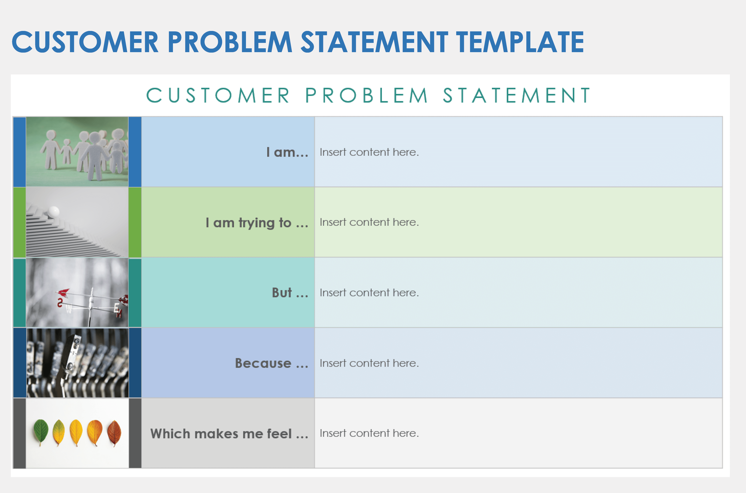

**Example:**

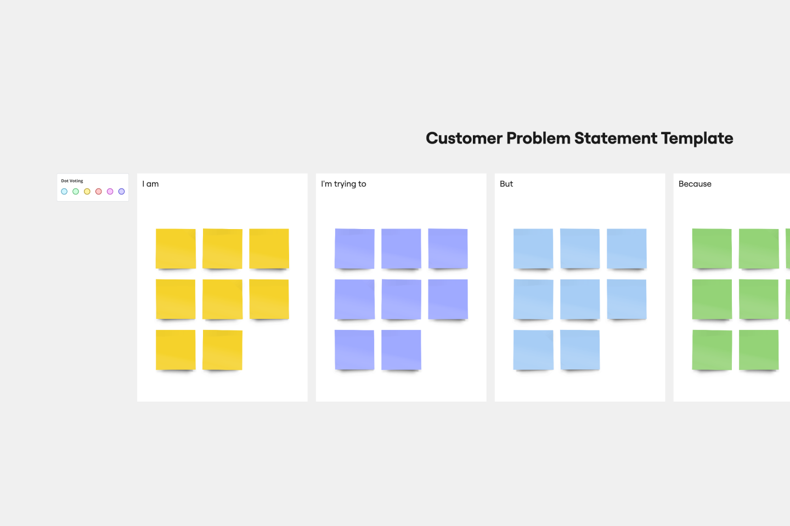

|  |  |  |  |  |  |
| --- | --- | --- | --- | --- | --- |
| **Problem Statement (PS)** | **I am (Customer)** | **I’m trying to** | **But** | **Because** | **Which makes me feel** |
| PS-1 | I am a citizen in need of government service information. | I’m trying to get fast, accurate information and report issues. | But I can’t find a single, reliable way to interact with government services. | Because there isn’t a unified, AI-powered conversational assistant available 24/7. | Which makes me feel frustrated, ignored, and discouraged from engaging. |
| PS-2 | I am a government official responsible for public service delivery. | I’m trying to monitor citizen sentiment and identify emerging issues. | But I’m relying on scattered, manual feedback channels that are slow to process. | Because there’s no centralized dashboard powered by AI to automatically analyze and visualize feedback in real time. | Which makes me feel reactive, overwhelmed, and unable to effectively improve services. |
| PS-3 | I am a rural/low-income citizen | I’m trying to access government services via digital tool | But I lack reliable internet or digital literacy | Because of the digital divide and no offline support | Which makes me feel excluded and unsupported |
| PS-4 | |  | | --- | |  |  |  | | --- | | I am a citizen concerned about data privacy | | I’m trying to provide honest feedback on public services | But I’m not sure how my data will be used or protected | Because the platform’s privacy policy and data handling are unclear | Which makes me feel skeptical and hesitant to participate |
| PS-5 | I am a community liaison in local government | I’m trying to reach diverse citizen groups | But engagement is skewed toward digitally savvy popula­tions | Because the platform doesn’t support multiple languages or outreach methods | Which makes me feel the process is biased and underrepresentative |